RELIABILITY ANALYSIS OF THE RED RIVER LEVEE
OF HA NOI, VIET NAM
Pham Quang Tu¹, Dang Quoc Tuan²
¹Thuy loi University, email: tupq@tlu.edu.vn
²Insitute for Pump and Water resources machine, email: qtuandh2@yahoo.com

1. INTRODUCTION
Red River Delta (RRD) is the second biggest delta in Viet Nam with the total area of around 15,500 sq.km and a population of nearly 20 million people. The delta is protected by approximately 3000 km of levees which are classiﬁed into four grades from III, II, I to special indicating the different safety levels. In this paper, the author ﬁrst establish the hydraulic boundary conditions and classify the geotechnical conditions of Red River levee in the area of Ha Noi, then carries out the classiﬁcation of dike base on ground condition and observation data. Finally, reliability indexes for each dike class indicated by three categories of levee such as A, B, and C, depending on its actual probability of failure. The ﬁnding is expected to be a good reference for ﬂood defence management in the RRD.
2. RELIABILITY ANALYSIS
2.1. Hydraulic boundary conditions
From the originally annual maximum discharge in Son Tay and Ha Noi gauging stations, the interpolating water levels are determined based on Q ~ H relationship which has been analysed through periods, then water level distribution can be evaluated for each dike section. Redistributed effect of the reservoirs results in probabilistic distributions of Q and H that formed the truncated distributions, see in Figure 1. It is noted that the target values of Q_{o} and H_{o} at Ha Noi are 22.000m³/s and 13,4m respectively, known as maximum discharge and water level after redistributed effect of the reservoirs. Typical ﬂood for calculation is chosen based on our predicted ﬂood waves in conjunction with ﬂood frequency. From [1], the author proved that water level will remain around 13,2 − 13,4m even when ﬂood frequency changes from 1/50 years in 1971 to 1/500 years for future situations. Furthermore, the ﬂood duration of the latter lasts longer than that of the former, from 89 to 119 hours.
2.2. Geotechnical conditions
Geotechnical conditions represents the resistance of dikes against the load, in this study, which is water level. It is noted that, the Delta is formed by various sediment formations through over a million year ago in Quaternary period. The ground are categorized into three main groups, indicating by I, II and III. Then, thickness and characteristics of impervious layers are mentioned due to their presence under dike foundation. Moreover, the observed failure mechanisms during the past 50 years such as piping, instability, termite activities, are analysed for each dike section. Finally, dike classiﬁcation are performed in Figure 2 with three categories 1, 2, and 3 indicating high, medium and low potential lead to dike failure. The parameters of soils for calculation could be found in [2, 3] .
2.3. Reliability analysis
Overﬂows leads to the collapse of levee because when water running over the dike crest excesses a certain discharge, it might cause the erosion of the inner slope. Overﬂowing phenomena happens if water level is higher than dike crest level, from [4], the overﬂow limit state function can be expressed as follows:
(1)
in which h_{d} is the height of dike crest; h_{c} is the critical overﬂow water head; h_{w} is the river water level. The parameters are used in the calculation as listed in Table 1.

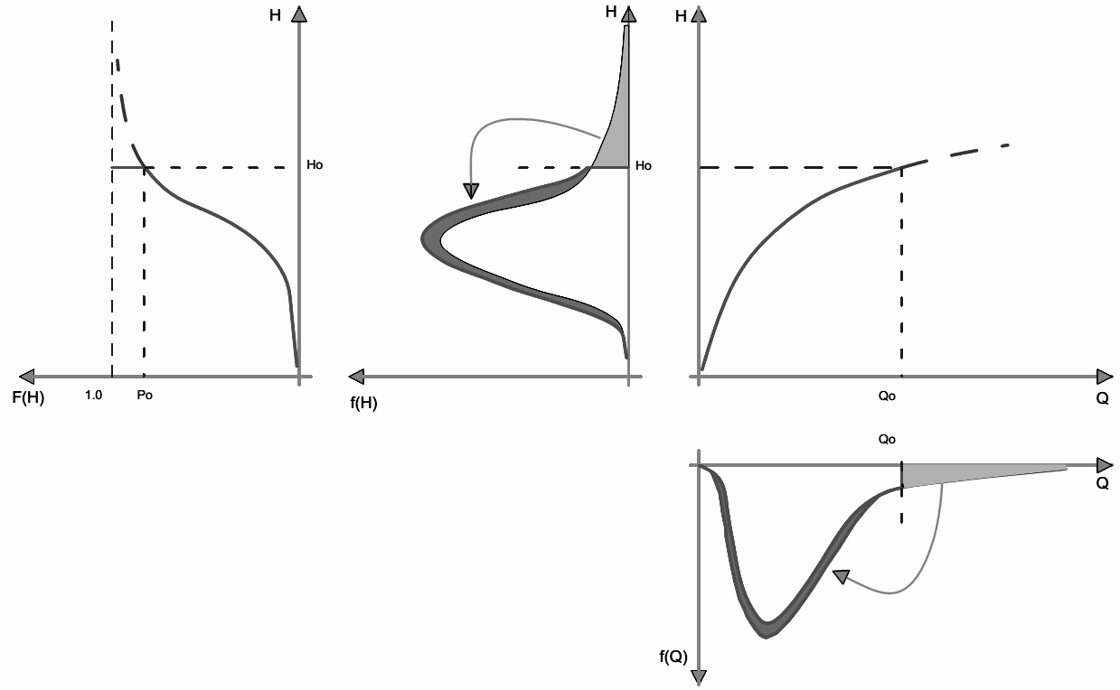
Figure 1: Truncated distribution of water
level and discharge
Piping happens under dike embankment due to the different water head between river and hinterland. The limit state function of piping mechanism given in [5] as follows:
(2)
with m_{p} is the model factor, here m_{p} = 1;
H is the river water level; d is the thickness of impervious layer; H_{b} is the water level in inside the dike ring and H_{c} is the critical head difference which will be estimated from
(3)
in which L is the horizontal seepage length; FR, FS, FG are factored coefficient depending on soil parameters. For more detailed see [3].
Instability and uplift are analysed together due to their combined effect on the failure of dikes. In [6], the authors performed a framework for uplift calculation. However, in this study, we integrate GeoStudio model (in term of instability) with a certain river water level. Soil property and water levels are randomly treated and the input data for calculation will be performed in [3].
2.4. Reliability analysis of the dike section
Dike section failure due to the failure from each related mechanism as a serial system. There are four failure mechanisms have analysed, then the failure probability of the levee segment could be determined as follows.
(4)
where P_{i} is the failure probability of mechanism i and P_{sec} is the failure probability of a section of levee. If mechanism i and j are independent (with i≠j), the failure probability of the system can be calculated by:
(5)
The ﬁnal result for the probability of failure of the dike sections are presented in Table 1 and Figure 2.
3. RESULTS AND DISCUSSION
From Figure 2 we can see that dikes in Red River in Ha Noi are classiﬁed in to different segments depending on the potential of failure. Dike type 3 is the most dangerous dike type in Ha Noi with the total length of 31.7km, equal to 32%. The failure probability of dike sections in this category are relatively high, over 1%. Instability analysis at dike section at Km78 shows highest probability of this failure with 8.1% comparing to 0,02-2% of other dike segments. The observation data also indicates that soft foundation is a main contributor to instability of dike section at Km78 with 15 failures locations in the past 40 years, see [7]. The next category of dike is type 2 that has a medium potential of failure, ranging from 1% to 1‰ with the total length of 34.2km. The last dike category was named type 1 with the lowest probability of failure (smaller than 1‰) compared to the two ﬁrst ones. There is 34.5km of dike, equal to 34% of total dike length. Sensitivity analysis also ﬁgured out that piping has been a dominant failure mechanism, and technical solutions for dike strengthening should focus on increasing the ground level of hinterland or controlling the river water level, see [8].
In conclusion, Red River dike around Ha Noi could be classiﬁed into three categories with probability of failure from low to high. Fundamentals of the classiﬁcation are impervious layer, observed phenomena, and characteristics of aquifer, then all conditions are combined to give the ﬁnal dike section categories. The results are expected to give a better understanding of ﬂood defence system of the Red River in Ha Noi.

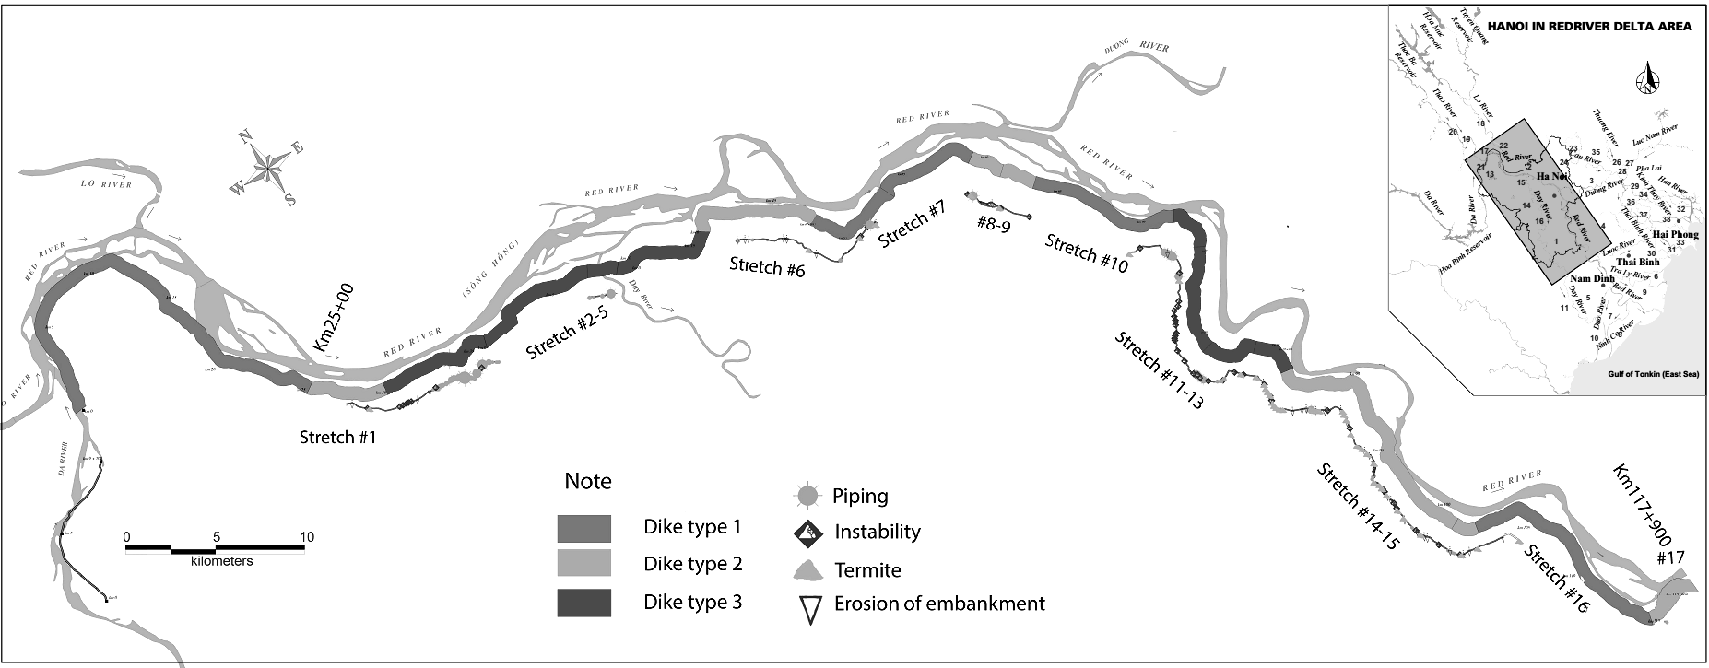
Figure 2: Classification of levee system in Ha Noi from
ground condition and observation data

Table 1: Summary of calculation results in typical dike segments

4. REFERENCES
- Ha, V.K., Study the scientific background for unflooded some lower area in the Red River basin and HoangLong River basin 2010.
- HEC, Geology investigation reports, Hanoi dikes improvement project 1994.
- Phạm Quang Tú, Reliability analysis of the Red River Dike system in Viet Nam, in Hydraulic Engineering. 2014, TU Delft: Delft. p. 215.
- Rijswaterstaat, Probabilistic design of flood defences, CUR 190. 1990, Gouda.
- Rijwaterstaat, Technical report on piping 1999.
- Van, M., A. Koelewijn, and F. Barends, Uplift phenomenon: Model, validation and Design. A feeling for soil and water, 2011.
- DDMFC, H., Report on current condition of river dike systems in Hanoi area before flood season 2009 2009, Department of Dikes Management and Flood Control of
Ha Noi.
- Tu, P.Q., et al. Red River Dike reliability analysis, from the past to the present. in Proceeding of 18th Southeast Asian geotehnical and Inaugural AGSSEA conference, Singapore 2013.

